8.56: Solving Eq. (8.4) for the ratio 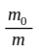, with 

